April 2025: Pune Testimonials Campaign
May 2025: Podcast featuring Dr. Vikram Shah
June 2025: Navigate with Finnovate - Rx Series launch
August 2025: Podcast with Dr. Hrishikesh Pai
September 2025: For the Doctor, By the Doctor Campaign (Short Film)
October 2025: Podcast with Dr. Sushil Shah
Launched Financial Glow-up - a personal finance Instagram Series
December 2025: Introduced departmental newsletter for internal alignment

Thought Leadership & Community Building
Published 6 editions of Doctor’s Financial Digest newsletter (till March 2026)
Executed flagship campaigns: FinnFit | FIRE | Retire Rich | Mutual Fund Mastery
Conducted 18 episodes of FinnFit Wednesday Webinar Series
Launched Wealth Rx Course
Built FinancialOPD Community - India’s first personal finance community for doctors
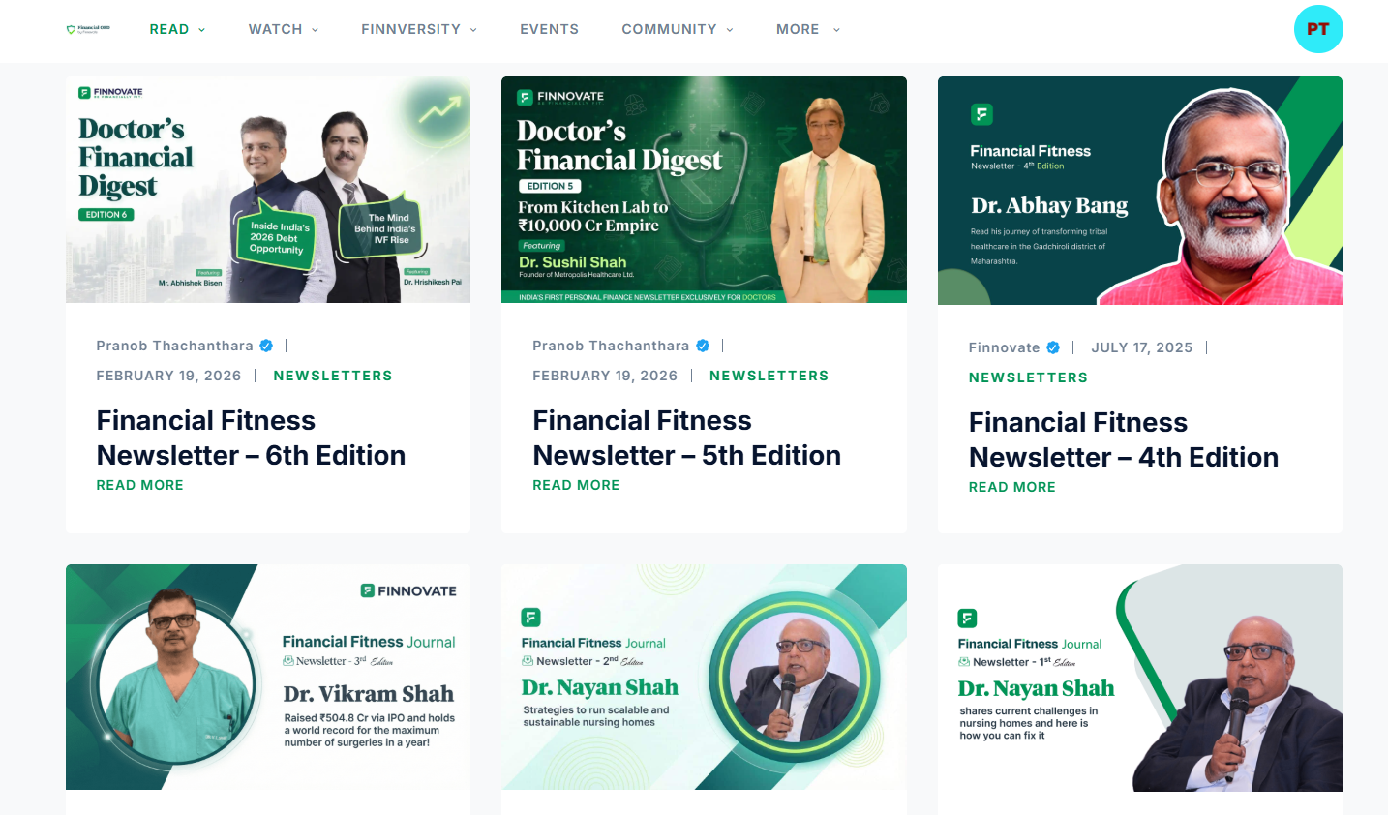
Newsletter

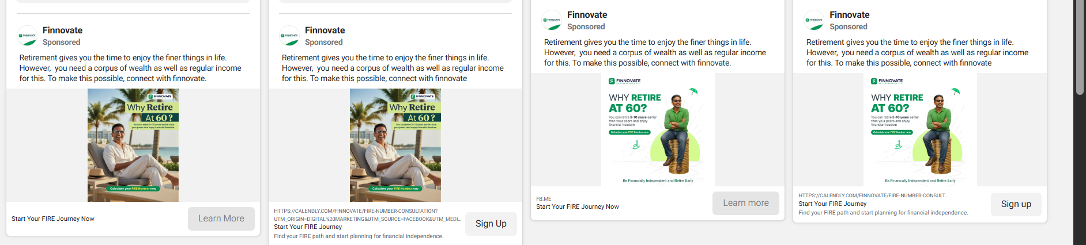

FIRE ads

FinnFit

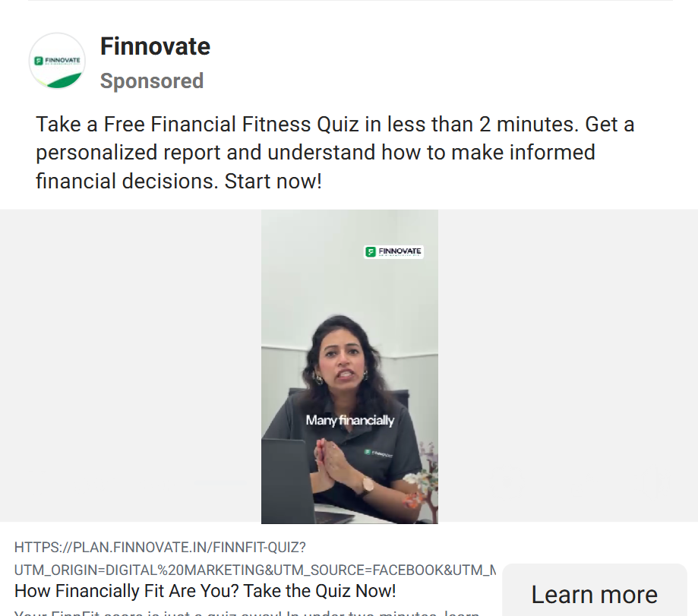

FinnFit Wednesday Webinar
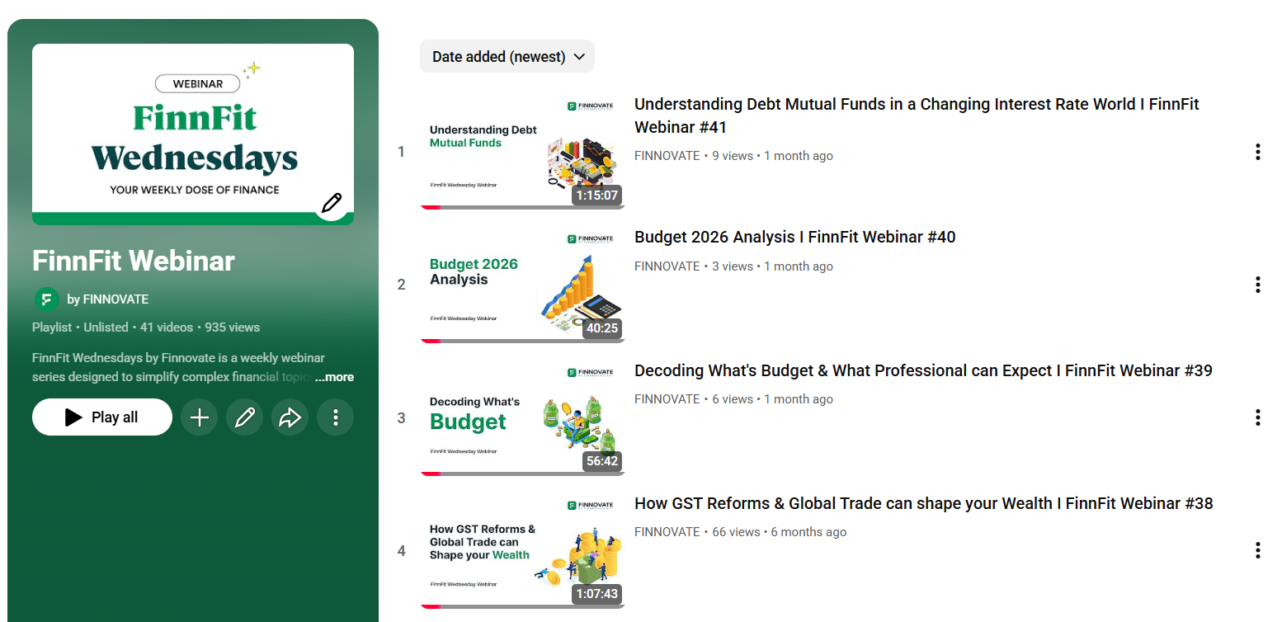

Digital Growth & Performance
Generated ~3000 digital leads
→ 1500 meetings booked
→ 440+ qualified meetings completed
Reduced digital lead cost by 50%+
Increased meeting booking rate by 40%
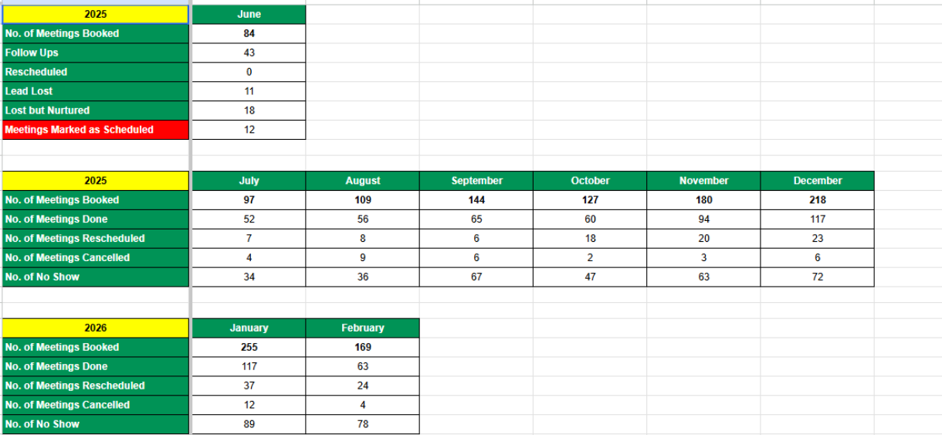

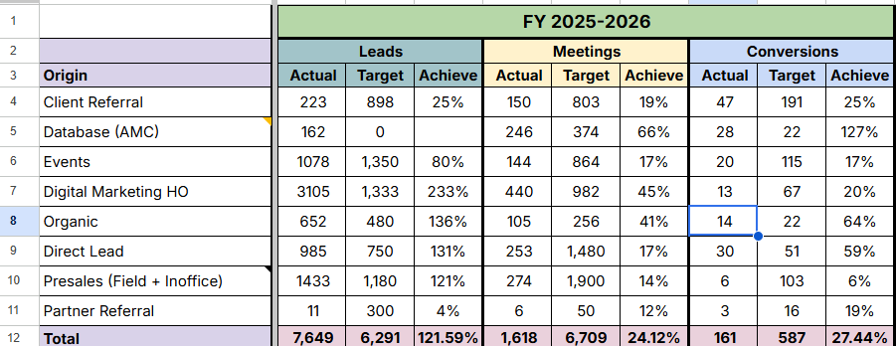

Website & Organic Growth
SEO & Traffic Growth:
Published 360 blogs
Increased organic clicks from ~1,700 to 15,000+ per month
Grew organic sessions from ~2,800 (Apr 2025) to 20,000+ (Mar 2026)

Product & Feature Enhancements:
Launched 8 financial calculators:
CAGR | SWP | XIRR | EMI | Child Education Planner | Loan Prepayment | Step-up SIP | HRA Exemption
Revamped website UX & SEO structure:
Homepage redesign
Improved blog layout
Enhanced media & podcast sections
Introduced location-specific pages (7 cities) for easier discovery of financial planners
Built a comprehensive FAQ section to address user queries

Conversion Improvements
Calendly bookings: Increased from 7 (Apr 2025) → 20+ (Feb 2026)
FinnFit Test participation: Increased from ~10/month → ~20/month

Content & Social Media Impact
Crossed 10,000+ followers on LinkedIn & 3,500+ followers on Instagram
Published 100+ unique content pieces across platforms - YouTube, Instagram, LinkedIn, Twitter (X)
Launched Fund ka Funda series, driving new subscriber growth

Events & On-Ground Presence
Hosted FinCon 2025 in Mumbai
Hosted Wealth Creation Chapters across Pune, Kutch, Ahmedabad, and Nashik
Organized HitCon Event - Ahmedabad
Improving the visibility and positioning of Finnovate

